Political Settlements and Revenue Bargaining (PSRB) Workshop

Program

Aarhus

August 10 – 12, 2022

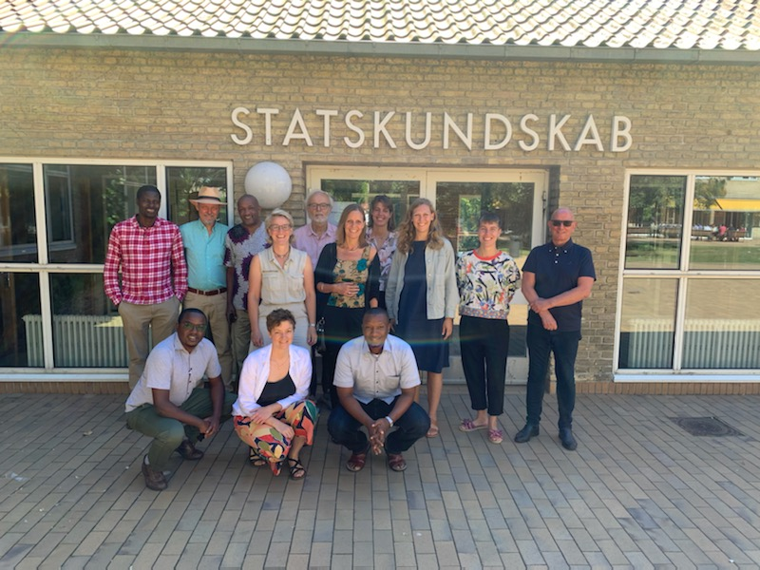

Table of content
The programme of the workshop 2
Day 1 – August 10 5
Introduction and welcome (Mette) 5
Concluding chapter of the Politics of Revenue Bargaining (Marianne and Ane) 6
Football and Tax (Jamal and Lucas) 7
Tax and governance in Uganda – presentation of ongoing research (Dan Ngabirano) 9
Paper based on PhD thesis (Mathilde) 10
The agricultural sector research as it turned out (Clayton and Mette) 12
Day 2 – August 11 14
Brokered fiscal contract in Senegal (Ane F) 14
Campaign financing: looking back (Moses, Jamal Ole) 15
Constantine’s paper based on thesis 17
Jamal: taxation and religious co production 19
Ane Edslev: presentation on informal traders and revenue bargaining 20
Odd-Helge Fjeldstad: On current research related to tax bargaining 22
Day 3 – August 12 24
Intro on presumptive tax reform: Mette 24
Presumptive tax reform in Uganda: Bakibinga, Clayton; Dan, Mette 24
Presumptive tax reform in Tanzania: Constantine, Ane E 25
Per Tidemand presents his work on local government financing in Uganda and draws parallels to Tanzania 27
Moses Khisa and Clayton: present ideas on agricultural sector reforms 30
Moses Khisa presents his work on tax exemptions 31
Workshop coming to an end and way forward 33

The programme of the workshop
Workshop Purpose:
- to present and discuss full paper drafts;
- To discuss ongoing projects and papers still to be produced
- to discuss publication and dissemination plans (website and others);
The first half of the workshop will be dedicated to looking back at some of the work we finished or almost finished.
The latter part of the workshop will be focused on looking forward….
August 8/9
Arrivals in Aarhus
Hotel CABINN Aarhus. Check-in at 15.00 and check-out at 11.00.
Kannikegade 14, 8000 Aarhus.
Direction: By foot from the train/bus station less than one kilometre (approx. 10 min). There are no public transportation options.

August 10
Location: Aarhus University building 1341 room 315
Link for Day 1: https://aarhusuniversity.zoom.us/j/66911085041
Direction: You can enter the building name (1341) in google maps to get directions either by foot (approx. 30 min.) or public transportation (approx. 15 min.)
The tram (L2) is the most convenient choice of public transportation and runs quite frequently. Three stops from ‘Skolebakken’ to ‘Aarhus Universitet (Ringgaden)’. Tickets can be purchased in a ticket machine at most stations (only card, no cash)
9.00 – 9.50 | Introduction and welcome: Presentation and discussion of the project, its progress etc. (Mette)
10 min break | Coffee, tea, fruits and snacks
10.00 – 11.00 | Marianne and Ane: concluding chapter of the Politics of Revenue bargaining
15 min break | Coffee, tea, fruits and snacks
11.15 – 12.15 | Jamal: taxation and religious co production  Slight change of programme: swapped places with the timeslot on Football and Tax (Day 2)
12.15 – 13.15 | Lunch
13.15 – 14.15 | Dan Ngabirano: Tax and governance in Uganda -presentation of ongoing research
15 min break | Coffee, tea and afternoon cake
14.30 – 15.30 | Matilde: paper based on PhD thesis
15.30 – 16.30 | Clayton and Mette: the agricultural sector research as it turned out
18.00 – 20.00 | Excursion ‘The Old Town’ and sandwiches (in the open)

August 11
Location: Aarhus University building 1341 room 315
Link for Day 2: https://aarhusuniversity.zoom.us/j/66347147014
9.00 – 10.00 | Ane: brokered fiscal contract in Senegal
10 min break | Refreshments: coffee, tea, fruits and snacks
10.10 – 11.10 | Campaign financing: looking back (Moses, Jamal Ole)
20 min break | Refreshments: coffee, tea, fruits and snacks
11.30 – 12.30 | Constantine – paper based on thesis
12.30 – 13.15 | Lunch
13.15 – 14.15 | Lucas (and Jamal): Football and Tax  Slight change of programme: swapped places with the timeslot ‘Taxation and Religious Co-production (Day 1)
14.15 – 15.15 | Ane Edslev: presentation on informal traders and revenue bargaining
15 min break | Coffee, tea and cake
15.30 – 16.15 | Odd-Helge Fjeldstad: On current research related to tax bargaining
Afternoon | Decentralized discussions on future work
18.30-21 | Workshop dinner  Location: Februarvej 6, 8210 Aarhus V (Mette’s house)

August 12
Location: Aarhus University building 1341 room 315
https://aarhusuniversity.zoom.us/j/63606245413
9.00 – 10.30 | Intro: Mette  Presumptive tax reform in Uganda: Bakibinga, Clayton; Dan, Mette  Presumptive tax reform in Tanzania: Constantine, Ane E
10 min break | Refreshments: coffee, tea, fruits, snacks
10.45 – 11.30  New location : 1325-136 | Per Tidemand presents his work on local government financing in Uganda and draws parallels to Tanzania
11.30 – 12.00 | Lucas and Mette present ideas on how to take the fiscal decentralization work further…. (was cut short)
12-12.30 | Moses Khisa and Clayton: present ideas on agricultural sector reforms
12.30 -13.15 | Lunch
13.15 – 14.15  Location 1341 - 315 | Moses Khisa presents his work on tax exemptions
14.15 – 15.15 | Publication and dissemination
15 min break | Refreshments: Coffee, tea and cake
15.30 – 16.30 | Summary

List of participants
Lucas Katera, REPOA
Jamal Msami, REPOA
Constantine George, REPOA, online
Anne Mette Kjær, Aarhus University
Ane Foged, Aarhus University
Moses Khisa, Northwestern
David Bakibinga, Makerere University, online
Dan Ngabirano, Makerere
Marianne Ulriksen, Southern Denmark University
Clayton Arinanye, online
Ole Therkildsen, DIIS
Ane Edslev, AU
Matilde Jeppesen, AU
Odd-Helge Fjeldstad
Per Tidemand (only present the last day)

